ICS 103 – Computer Programming in C
Spring Semester 2011-2012 (Term-112)
Lab #12: Strings

Objective:
Practice how to use Strings.

String Declaration & Initialization
• A string is a list of characters enclosed in double quotes. It is represented in C as an array of characters
• However, one additional cell is required for storing the terminating character, ’\0’,called NULL
• Example: Even though the string ”I like C” has 8 characters, we need to declare an array of size 9.

char str[9]=”I like C”;
’I’ | ’ ’ | ’l’ | ’i’ | ’k’ | ’e’ | ’ ’ | ’C’ | ’\0’
Note that in the example above, the null character is automatically inserted by the compiler

• All the string functions in C require the presence of the NULL character to work correctly.
• Strings can also be declared without specifying the size as in:
char str[]=”I like C”;
In this case, sufficient storage is allocated including that for NULL
• Like array, the individual characters of a string can be accessed by specifying the index. Example, assuming the above assignment, str[4] is the character ‘k’

Consider the following example where the program reads the characters of the string character by character. The last character read is ‘\n’ (Enter key). Once outside the loop we assign the NULL character ‘\0’ at the location of ‘\n’ to make the sequence of characters a string. Now run the example and see what happens when you comment or uncomment the statement assigning the ‘\0’ character.

#include <stdio.h>
int main () {
char st[80];
int i=0;
printf("Enter Text >");
scanf("%c",&st[i]);
while (st[i]!='\n') {
i++;
scanf("%c",&st[i]);
}
//st[i]='\0';
puts(st);
return 0;
}
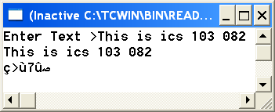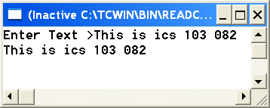
Statement commented statement uncommented
As you see when the null character is not assigned to the location after the last character of the string, the 1-D array of type char is not considered as a string. This is clear from the first case showing some strange characters printed after the ‘\n’ character.

String I/O
• The easiest way to input string is by using the gets function

Example: char name[81];

printf(”Input your name”);

gets(name);
gets allows you to read a string that could include blanks. It reads all characters including blanks up to pressing the “ENTER” key. The “ENTER” key (‘\n’) character will not be part of the string.
• Also the easiest way to output string is by using the puts function as in:

puts(name);
• For scanning from file, we have fgets(str, n, file) which expects 3 arguments: string variable, number of characters to scan and the file to scan from. If end of line (‘\n’) is encountered before scanning n-1 characters, fgets will stop reading otherwise it reads n-1 characters.
• Also we can print into a file using fputs(str, file).
• You can also use the scanf/printf functions for string I/O using the %s format specifier.
• However, scanf terminates reading on encountering the blank character, so first and last names must be read separately:

char first[10],last[10],full[20];

printf(”\nEnter your first name: ”);

scanf(”%s”,first);

printf(”\nEnter your last name: ”);

scanf(”%s”,last);

printf(”\nYour full name is : %s %s”,first,last);
• Note that the address of operator, &, is not used in the scanf function.

Built-in string functions:
Built-in string processing functions can be accessed through the header file, string.h . Some of these are:
• strcat(string1, string2) à appends strings2 to string1
• strcpy(string1, string2) à replaces string1 with string2
• strlen(string1) à returns the length of string1 excluding NULL character
• strchr(string, ch) à searches for the occurrence of ch in string
• strstr (string1, string2) à searches for the occurrence of string2 in string1
• strcmp(string1, string2) à compares string1 and string2 and returns:
o Negative integer if string1 < string2
o 0 if string1 = = string2
o positive integer if string1 > string2.

The following program illustrates the use of some string functions:

#include <string.h>

#include <stdio.h>

main() {

char s1[81], s2[81];

gets(s1);

gets(s2);

printf(”lengths: %d %d\n”, strlen(s1), strlen(s2));

if (!strcmp(s1, s2))

printf(”The strings are equal\n”);

strcat(s1,s2);

printf(”%s\n”,s1);

return 0;

}

Note: It is important to remember that strcmp() returns 0 if the strings are equal.
Built-in character functions:
• Built-in character functions can be accessed through the header file, ctype.h
• Some of the common functions are:
• isupper(ch) à returns nonzero if ch is uppercase, returns 0 otherwise
• islower(ch) à returns nonzero if ch is lowercase, returns 0 otherwise
• isalpha(ch) à returns nonzero if ch is an alphabet (lower or upper case) or 0
otherwise
• isalnum(ch) à returns nonzero if ch is an alphabet (lower or upper case) or a
digit (0,1,..9), or 0 otherwise
• isdigit(ch) → returns nonzero if ch is a digit (0, 1, …, 9) or 0 otherwise
• tolower(ch) à converts a character to its lower case if it has one
• toupper(ch) à converts a character to its upper case if it has one

Exercises:

Exercise 1:
Write a program that reads some text from the user, then calls a function called modify that you need to write.
This function receives a string and does the following changes:
-Each capital letter is converted to lower case
- Each lower case letter is converted to capital letter
-Each digit is incremented by 1, except 9 which becomes 0.
-Each other character is replaced by #
After calling the function modify, your program displays the modified text.

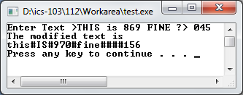

Exercise 2:
Write a function search_char that receives a string and a character and returns the index of the character if it is present in the string or -1 otherwise. The function is similar to linear search function but works with characters.
Note: You need to use linear_search function seen in previous lab and modify it so that it searches for a character instead of a number.
Write a main function to test your function as shown below.
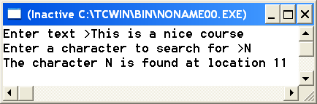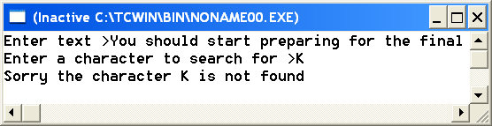

Exercise 3:
The following is an implementation of the function strcmp.
int strcmp (char s1[], char s2[]) {
int i;
for (i=0; s1[i]!=’\0’&&s2[i]!=’\0’; i++ ) {
if(s1[i]!=s2[i])
return s1[i]-s2[i];
}
return s1[i]-s2[i];
}

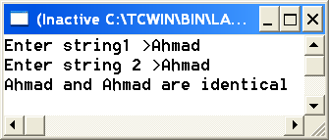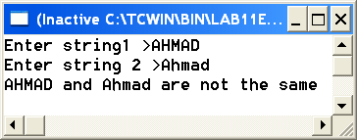
As shown in the second run, the function strcmp is case sensitive. You need to modify strcmp and call it my_strcmp so that it is case insensitive. Write a main function to test it as shown below.
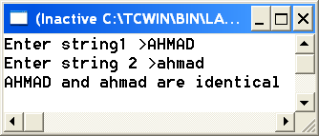

Exercise 4:

Write a function that receives a string and sort it alphabetically using selection sort. The sorting should be case insensitive as in exercise 3. You need to modify selection_sort function used for numbers so that you apply it for characters.
Test your function as shown below.

